**12 ДЗ - RBAC контроль доступа, квоты и ограничения.**

**Собираем Dockerfile и docker-compose.**

clickhouse-25.2.1.Dockerfile:  
  
FROM clickhouse/clickhouse-server:25.2.1

MAINTAINER Maksim Kulikov <max.uoles@rambler.ru>

RUN apt-get update -y --fix-missing

RUN DEBIAN_FRONTEND=noninteractive apt-get -yq upgrade

RUN apt-get install nano mc python3 pip kafkacat -y

RUN pip install clickhouse_driver

EXPOSE 8123 9000

ENTRYPOINT ["/entrypoint.sh"]

Собираем образ командой:

docker build -f clickhouse-25.2.1.Dockerfile -t uoles/clickhouse:25.2.1 .

Запускаем:

docker run -d \

-p 18123:8123 \

-p 19000:9000 \

-e CLICKHOUSE_DB=my_database \

-e CLICKHOUSE_USER=username \

-e CLICKHOUSE_DEFAULT_ACCESS_MANAGEMENT=1 \

-e CLICKHOUSE_PASSWORD=password \

--name clickhouse-server \

--ulimit nofile=262144:262144 \

uoles/clickhouse:25.2.1

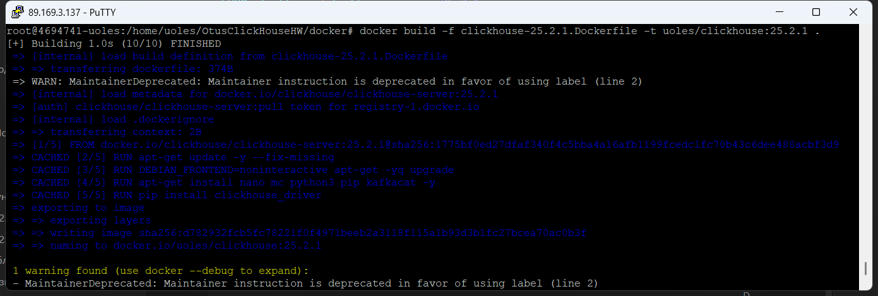

**Создание пользователя и роли.**

Выполняем запросы:

**CREATE** **USER** jhon IDENTIFIED **WITH** sha256_password **BY** 'qwerty'

**CREATE** **ROLE** devs;

**GRANT** **SELECT** **ON** my_database.* **TO** devs;

**GRANT** devs **TO** jhon;

Проверяем наличие пользователя и роли:

**SELECT** name,

auth_type,

auth_params

FROM system.users

**WHERE** storage = 'local_directory'

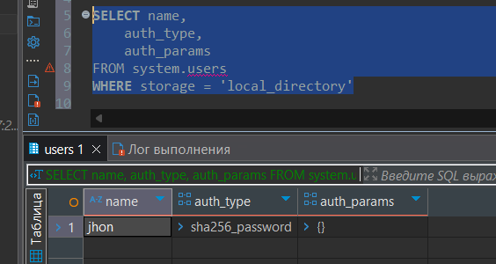

**SELECT** *

**FROM** system.roles

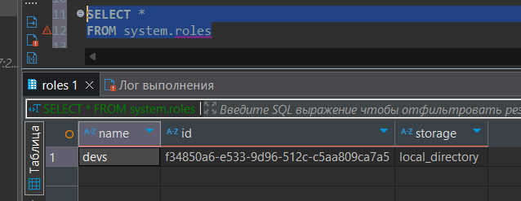

**SELECT** *

**FROM** system.role_grants

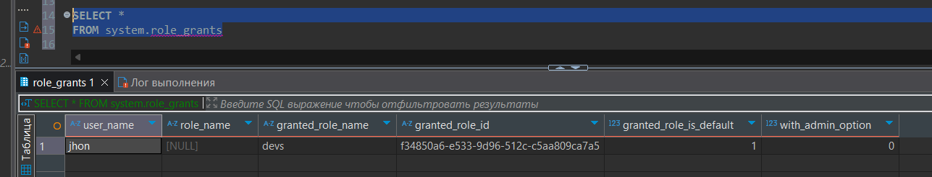

**SELECT**

grants.user_name,

grants.role_name,

users.name **AS** *role_member*,

grants.access_type,

grants.**database**,

grants.**table**

**FROM** system.grants

**LEFT** **JOIN** system.role_grants **ON** grants.role_name = role_grants.granted_role_name

**LEFT** **JOIN** system.users **ON** role_grants.user_name = users.name

**WHERE** users.name = 'jhon'

